1)htpp->HHTP server

2) ngnix

3)IHS->Microssft

4)Oracle HTTPD

5)IBM HTTDP

6)

127.0.0.1 ->localhost/ loop back address ->would be use to test if a network works

An Is card

Parts of url:

Protocol – Url (uniform located)– resources /process

#

C:\Users\PC>tracert 172.217.13.110

Traza a la dirección yul02s04-in-f14.1e100.net [172.217.13.110]

sobre un máximo de 30 saltos:

1 2 ms 1 ms 1 ms 192.168.5.1

2 17 ms 14 ms 36 ms modemcable001.161-131-66.mc.videotron.ca [66.131.161.1]

3 15 ms 26 ms 96 ms 10.170.154.42

4 11 ms 56 ms 16 ms 72.14.216.228

5 17 ms 107 ms 9 ms 108.170.228.22

6 13 ms 125 ms 99 ms 108.170.231.59

7 11 ms 121 ms 12 ms yul02s04-in-f14.1e100.net [172.217.13.110] “google server”

What is hops in a network?

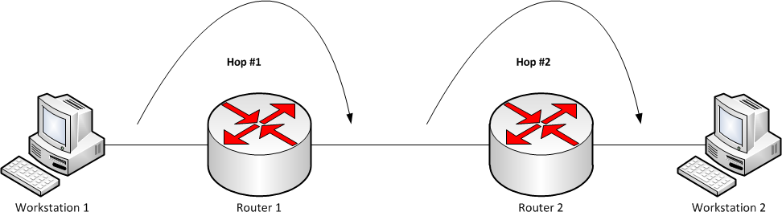In computer networks, a hop is an intermediate connection in a string of connections linking two devices. Whenever a router or gateway is an intermediary device between two different and remote hosts, nodes or networks, it is known as a hop.

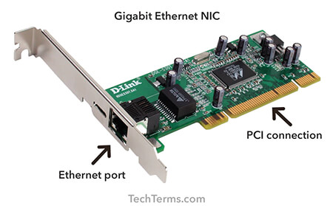NIC stands for Network Interface Card. It's a hardware component that connects a computer or other device to a network. The NIC provides the physical interface between the device and the network, allowing the device to send and receive data over the network. NICs are commonly used for connecting computers to local area networks (LANs) or other types of networks, such as wireless networks or the internet.

<audio src=”” controls loop> </audio> tag for posting audion in my webpage

>Section id=”> --> for redirection my menu to some section in my page it’s gonna be used the section tag

<!DOCTYPE html>

<html>

<head>

<title>Sample Table</title>

</head>

<body>

<h1>Employee Information</h1>

<table border="1">

<thead>

<tr>

<th>ID</th>

<th>Name</th>

<th>Position</th>

<th>Salary</th>

</tr>

</thead>

<tbody>

<tr>

<td>1</td>

<td>John Doe</td>

<td>Software Engineer</td>

<td>$80,000</td>

</tr>

<tr>

<td>2</td>

<td>Jane Smith</td>

<td>Designer</td>

<td>$70,000</td>

</tr>

<tr>

<td>3</td>

<td>Michael Johnson</td>

<td>Project Manager</td>

<td>$90,000</td>

</tr>

</tbody>

</table>

</body>

</html>

What is php used for?

It’s used to process dynamic data. It allows developers to create interactive and data-driven websites by embedding PHP code within HTML. PHP can handle form data, interact with databases, manage sessions, and perform various other server-side tasks.